6.4 Nappy changing

Policy statement

No child is excluded from participating in our setting who may, for any reason, not yet be toilet trained and who may still be wearing nappies or equivalent. We work with parents towards toilet training, unless there are medical or other developmental reasons why this may not be appropriate at the time.

We provide nappy changing facilities and exercise good hygiene practices in order to accommodate children who are not yet toilet trained.

We see toilet training as a self-care skill that children have the opportunity to learn with the full support and non-judgemental concern of adults.

Procedures

- Children from two years should normally wear pull ups, or other types of trainer pants, as soon as they are comfortable with this and their parents agree.
- Changing areas are warm with safe areas to lay children.
- Gloves and aprons are put on by staff before changing starts and the areas are prepared. Paper towel is put down on the changing mat freshly for each child.
- All staff are familiar with the hygiene procedures and carry these out when changing nappies.
- In addition, key persons ensure that nappy changing is relaxed and a time to promote independence in young children.
- All children are changed within sight of other staff whilst maintaining their dignity and privacy at all times.
- Children are encouraged to take an interest in using the toilet; they may just want to sit on it and talk to a friend who is also using the toilet.
- Children are encouraged to wash their hands, and have soap and towels to hand. They should be allowed time for some play as they explore the water and the soap.
- Anti-bacterial hand wash liquid or soap should not be used for young children; young skin is quite delicate and anti-bacterial products kill off certain good bacteria that children need to develop their own natural resistance to infection.
- Key persons are gentle when changing; they avoid pulling faces and making negative comments about ‘nappy contents’.
- Key persons do not make inappropriate comments about children’s genitals when changing their nappies.
- Older children access the toilet when they have the need to and are encouraged to be independent.
- Nappies and pull ups are disposed of hygienically. Any soil (faeces) in nappies or pull ups is flushed down the toilet and the nappy or pull up is bagged and put in the bin. Cloth nappies, trainer pants and ordinary pants that have been wet or soiled are bagged for the parent to take home.
- We have a ‘duty of care’ towards children’s personal needs. If children are left in wet or soiled nappies/pull ups in the setting this may constitute neglect and will be a disciplinary matter.
- If a child flatly refuses to allow staff to change a wet or soiled nappy and there is more than thirty minutes of a session left we will call the childs parent/carer and act upon your instructions.
- If a child is not yet potty trained, we request you send a named bag daily to be left on your childs coat peg to include a supply of nappies/pull ups and pants, nappy sacs, cream, wipes etc that you would like us to use
- We have a limited supply of spare clothes etc, in case of accidents we request if you have used these that you launder them and return to playgroup asap.

This policy was adopted at a meeting of | South Cerney Pre-school Playgroup | (name of provider)
Held on | 10.7.24 | (date)
Date to be reviewed | 10.7.25 | (date)
Signed on behalf of the provider | 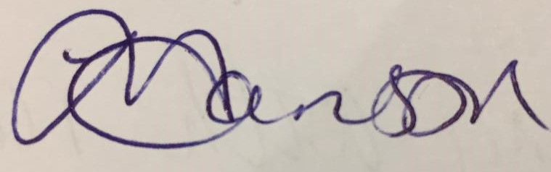
Name of signatory | Jo Hanson
Role of signatory (e.g. chair, director or owner) | Chairperson

